Scratch Activity: Scratch Teacher Accounts

ScratchMaths 2017 @ the University of Newcastle

# Activity Introduction

In this activity, you will learn about some important features of *Scratch Teacher Accounts*. A *Teacher Account* allows you to manage *Classes* of students and can make common administrative tasks, for example: setting up students' accounts and changing students' passwords, easier. We highly recommend requesting a *Teacher Account* on the *Scratch* website, if you are going to use the online version of *Scratch* with your students.

The features of the *Scratch Teacher Accounts* we will focus on in this activity are:

* Creating a *Class*
* Adding *Students* to a *Classs*
* Creating *Class Studios*
* Changing *Students'* passwords
* Viewing *Students'* Activity

*Teacher Accounts* in *Scratch* have only been introduced recently, so there may be changes to the *Teacher Account* features or new features introduced soon. For more information about what *Teacher Accounts* can and cannot do, and the changes that are planned for the future, we recommend reading the [Scratch Teacher Account FAQ](https://scratch.mit.edu/educators/faq).

# Key Teacher Account Concepts

In this activity, there are several concepts/terms that we have used frequently. We have included a short description of these frequently used concepts/terms, in case you need to to know what these mean or refer to them when working through the different sections of the activity.

## Student Account

A **Student Account** is a *Scratch* account that has been created by a *Teacher Account*. **Student Accounts** differ to regular Scratch Accounts (those that are created by signing up on the homepage) in two main ways. Firstly, a **Student Account** belongs to a *Class* that has been set up by a teacher. Secondly, you do not need to register a student's email with a **Student Account**. Consequently, if one of your students with a **Student Account** forgets their password and cannot log in to their account, you will have to change their password using your *Teacher Account*.

Currently, a **Student Account** can only belong to one class and the account cannot be changed to another class. For example, if a teacher in Year 6 has their own *Teacher Account*, the *Student Accounts* in the Year 5 teacher's *Class* cannot be transferred to the Year 6 teacher's *Class* at the end of the year. This is discussed in more detail in the *What are Classes in Scratch?* section of this activity.

## Teacher Account:

A **Teacher Account** is a *Scratch* account that has been requested from, and approved by, the *MIT Scratch* team. With a **Teacher Account,** you can create and manage *Classes* of *Student Accounts*, as well as access *Educator Resources*.

When you are signed into a **Teacher Account** in Scratch, you will see a purple banner at the top of the homepage, as shown in the picture below:

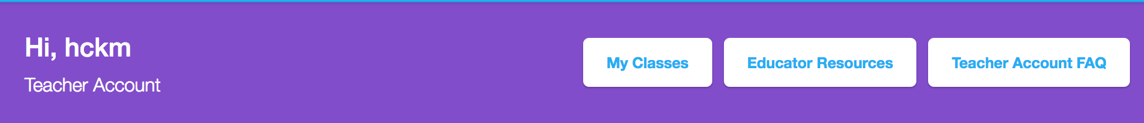

You may also notice that, in the menu at the top-right of the screen you will have an extra item: *My Classes* when signed into a **Teacher Account**, as illustrated below:

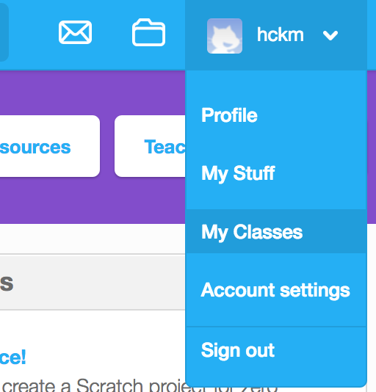

In addition to allowing you to manage *Classes*, **Teacher Accounts** also allow you to use *Scratch* to create, remix and share projects, just like you can with regular *Scratch* accounts.

## Classes

In *Scratch*, *Classes* are a collection of *Student Accounts* For example, if you teach a Year 5 class, then you might create a *Class* that has *Student Accounts* for all of the students in that Year 5 class.

How you use *Classes* will depend on what works best for your students. Different approaches of using *Classes* are discussed in more detail in the *What are Classes in Scratch* section of this activity.

## Class Studios

A **Class Studio** is a collection of *Scratch* projects that belongs to a *Class*. You can create as many **Class Studios** for a *Class* as you would like, and all of the *Student Accounts* in that *Class* will be able to view and add projects to them.

There are several reasons for using **Class Studios**. For example, you could set up a **Class Studio** as a way for students to submit a *Scratch* program for assessment. Once students complete their project, they can share the project and add it to the **Class Studio** for you to view and assess. Other examples where **Class Studios** could be used are discussed in the *What are Class Studios?* section of this activity.

# Creating a Class

## What are Classes in Scratch?

One of the most important concepts in this activity is: *Classes*. In *Scratch*, a *Class* is a collection of *Student Accounts*. You can create as many *Classes* as you would like and and each of these *Classes* can have as many *Student Accounts* in them as you would like. Currently, *Student Accounts* can only belong to one *Class* and cannot be moved between different *Classes*. Additionally, if your students are already using *Scratch* and have their own regular *Scratch* accounts, you cannot add their regular *Scratch* accounts to a *Class*. However, the ability to move *Student Accounts* between *Classes* and add regular *Scratch* accounts to *Classes* may be added in the future.

If you decide to use *Scratch Teacher Accounts*, the way that you will create use *Classes* for your school will depend on how many classes you teach and whether different teachers at your school also use Scratch. For example, if you teach a Year 5 class Mathematics with *Scratch* and another teacher sees the same class for a stand-alone ICT lesson that also involves *Scratch*, you may want to set up a shared account with the teacher that runs the ICT lesson. This way, your students can use the same *username* and *password* in your class and in the ICT lessons. Additionally, you and the ICT teacher will also be able to see students' activity and manage their accounts as well.

If you have any other questions about using *Classes*, or if you already using *Classes* and would like to share how you use them with your students with us, please let us know.

## Adding a New Class

Now, we will add a new *Class* using your *Teacher Account*.

You can get to the *My Classes* page, where you can view and manage your *Classes*, by clicking on the *My Classes* button in the purple banner on the *Scratch* homepage or by clicking the *My Classes* link in the drop-down menu on the top-right of the screen.

To add a new class, click the *+ New Class* button and you should see a form similar to the one pictured below:

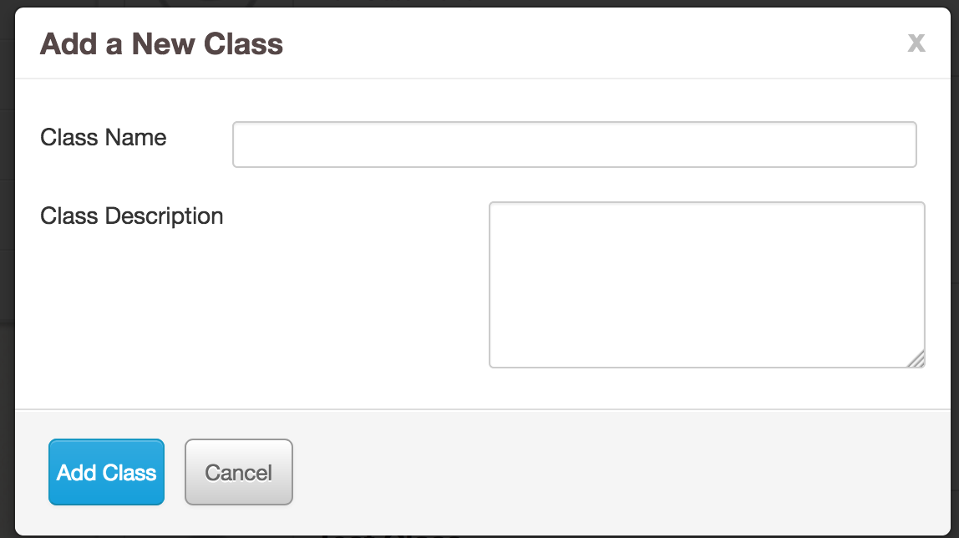

You are welcome to name the *Class* with any *Class Name* and put in any *Class Description* that you like. However, you should be aware that the *Classes*, *Student Accounts*, *Class Studios* and your students' shared projects can be viewed by anyone on the *Scratch* website. Consequently, when you create a *Class* for your students you should probably not put information about the *Class* in the *Class Name* or *Class Description* textboxes that could reveal your school or the identity of your students.

After choosing a *Class Name*, writing a *Class Description* and clicking the *Add Class* button, the *Add a New Class* form should disappear and you will see the newly created *Class* in the *All Classes* list.

In the next section you will learn about how to add *Student Accounts* to a *Class*.

# Adding Students to Classes

There are currently three different ways to add *Students* to a *Class* with *Scratch Teacher Accounts*:

* Adding *Students* with the *+ New Student* button
* Adding *Students* with CSV Upload
* Creating a *Student* Sign-up Link

Each of these methods of adding students are slightly different and none of them is the "best way". If you decide to use *Scratch Teacher Accounts* with your classes, you can use whichever of these methods you like. We discuss one approach that you could use in the *Which Way Do We Recommend Adding Students?*, that we have used successfully for creating accounts for professional development workshops. However, you may find that one of the other approaches is better suited to your students and classrooms.

## Adding Students with the *+ New Student* button

### How the *+ New Student* Button Works

The *+ New Student* Button allows you to add *Student* accounts to a *Class* one at a time. When you add a new student with this approach, you choose their account's *username*. The new student can then log in by using the *username* and the name of your account as the password. So, for example, if your Teacher Account's name is *ScratchTeacher*, then the first time the student logs into their account that you have created with the *+ New Student* button, they will use the password: *ScratchTeacher* to login. Once that student has logged in to Scratch, they will then be prompted to choose a new password.

This method of adding students can be quick and easy, as long as you only have to create *Student Accounts* for a small number of students. If you have a class of 20 or more students and have to create accounts for all of them, we would recommend that you use one of the other approaches discussed in the next sections.

### Add a Student with the *+ New Student* Button

To add a student, click the *+ New Student* button in the *Students* tab, when viewing the *Class* you created in the previous activity section. You should now see a form similar to the one pictured below:

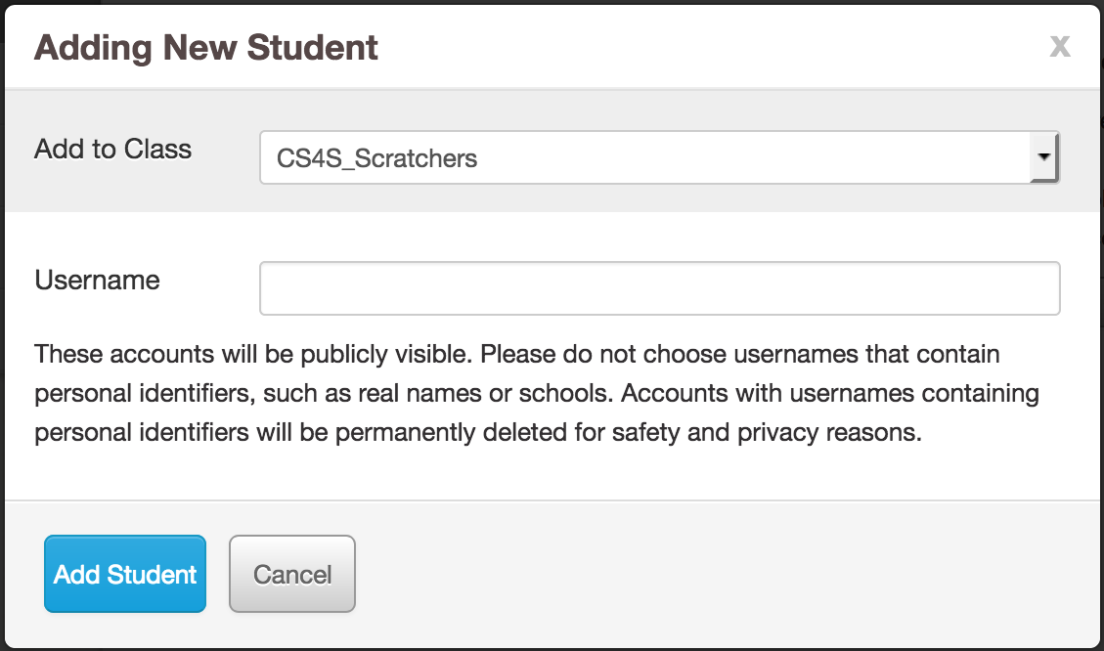

Try and see what happens when you enter a common name (for example: *Bob*) in the *Username* textbox and click the *Add Student* button.

You are likely to get a message that says: *Sorry, that username already exists*. As Scratch has a large number of members, it may be difficult to find *usernames* that have not already been taken when creating accounts for your students.

Generally, when creating accounts for workshops we prefix the *username* with a meaningful acronym (for example: *SM* for *ScratchMaths*) and then use a combination of random colours, animal names and numbers for the rest of the username. For example, we may use *usernames* like *SM_BlueDog22* for the accounts we create, because they do not contain names or other words that could identify who the account belongs to and they are also unlikely to be already taken by someone else.

You may want to take a similar approach when you create a class of students, but you are welcome to use any *usernames* of your choosing for this activity.

Now, add a Student with the *Adding New Student* form by creating a unique *username* and clicking the *Add Student* button. If all the *usernames* you think of are not unique, keep trying to complete the form until you create a *username* that does not already exist or ask one of the workshop presenters to help you come up with a unique *username*.

When you have successfully added a student, the form pictured above will disappear and the *Student* account you just created will appear in the list of accounts in the *Students* tab.

### Log into the New Student's Account

Now we will log into the newly created *Student's* account, so that you can see what the student will experience when logging into their account created with *+ New Student* button.

Firstly, open another web browser (for example: if you are using *Firefox* - open *Chrome* as well). In that web browser, go to the *Scratch* homepage at [scratch.mit.edu](https://scratch.mit.edu/).

Log in to the *Scratch* account you created by clicking the *Sign in* button and:

* Put the username of the Student account you created in the steps above in the *Username* textbox
* Put the name of your *Teacher Account* in the *Password* textbox

Once you have logged into the student's account, you should a message about being invited to the *Class* you created earlier. Click the *Get Started* button and you will then been prompted to choose your own *password*. Once you have chosen your own *password*, you will have to complete a form of personal details. After completing that form, you have now finished logging in to the new *Student's Account* and will then be able to view the *Class* from that account's perspective.

### Summary

* The *+ New Student* Button allows you to add *Student* accounts to a *Class* one at a time
* This approach requires that you choose a (unique) *username* for each of the *Student* accounts you create
* The *Student's* account's *password*, when they first log in, will be the *username* of your *Teacher Account*
* The *Student* will be prompted to change their *password* once they have accepted the invitation to the *Class*, after logging in for the first time
* This approach can be quick and easy for creating a small number of accounts for students but the other approaches in the next sections may be better for 20 or more students

## Adding Students with CSV Upload

### How It Works

The *CSV Upload* approach is effective for creating lots of *Student* accounts quickly. The *CSV Upload* involves creating a csv (*comma separated values*) file that has a list of the usernames and passwords for the new accounts you would like to create.

An example of the format of the csv file that is expected for the *CSV Upload* is shown in the image below.

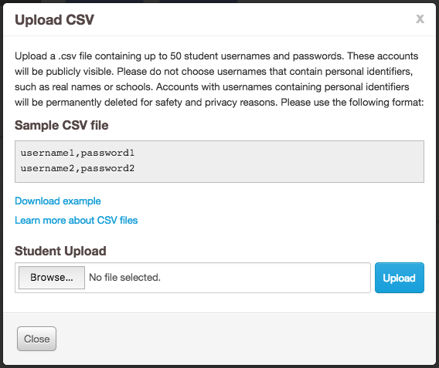

The *Sample CSV file* in the above image has 2 lines and therefore, when uploaded, would result in the creation of 2 *Student Accounts*:

* One account with the username: *username1* and password: *password1*
* The other account with the username: *username2* and password: *password2*

We will step through the process of creating our own csv file and uploading it in the next part of this section.

As you saw in the previous section, new *Student* accounts have to be named uniquely. If one or more of the usernames in the csv file is already taken, a message will appear that alerts you that the *username/s* already exist.

Using the accounts in the example above, if we try and upload a csv file with *username1* and *username2* as the new account names, we will receive the following error message:

* *Row 1: username: Already exists*
* *Row 2: username: Already exists*
* *Please update the CSV file to address the issues above and reload the file.*

This error message is telling us that the *username* on Row 1 (the first username in our csv file) and *username* on Row 2 (the second username in our csv file) have already been registered by other Scratch users. If we changed these *usernames* so that they were unique and uploaded the csv file again, then the error message would disappear and the newly created *Student Accounts* would appear in the *Students* tab of the *Class*.

If you do use the *CSV Upload* approach, all of the *usernames* in your csv file may not exist already and consequently you may not encounter this problem. However, it may be useful to know that if you do see the error mesage about the *usernames* already existing (or another error message), then none of the accounts will be created until you have fixed the problem and uploaded the csv file again.

### Create and Upload a CSV File for New Student Accounts

Now, we will add two new *Student Accounts* to our *Class* by creating and uploading a csv file.

You can create a csv file in several programs, including *Excel*, or in any plain-text editor (for example: *Notepad* on Windows or *TextEdit* on Mac OSX). In this example, we will use the *Notepad* program to create the csv file.

There are two lines below that you will have to write into *Notepad*. You will have to replace the ^^ letters in the lines below with your initials, to ensure that the *usernames* in the csv files are unique.

**SM_CSVUpload_^^_1,password1**

**SM_CSUpload_^^_2,password2**

For example, if your name is *Bob Green*, the first line of the file in *Notepad* will be *SM_CSVUpload_BG_1,password1*

After adding these two lines in a document in *Notepad*, save the file in a place on the lab computer that is easy to find (for example: the Desktop).

Back in the web browser that you have logged into your Scratch *Teacher Account*, follow these steps:

1. Click the *CSV Upload* button in the *Students* tab of your *Class*
2. Click the *Browse* button and select the file you just created in *Notepad*
3. Click the *Upload* button

After following these steps, the *Upload CSV* form will disappear and the two new accounts from the csv file should now appear in the *Student* tab of your *Class*.

### Log in to One of the Student Accounts

Now, we will log into one of the *Student Accounts* you created through the process of uploading the csv file. Go back to the web browser that you had opened to log in to the account in the previous section, where you learned about the *+ New Student* button, and sign out of that account.

Now, click the *Sign In* button and log into one of the accounts you created through the *CSV upload*.

If your name is Bob Green, you could sign into one of your newly created *Student Accounts* by:

* Putting *SM_CSVUpload_BG_1* in the *Username* textbox
* Putting *password1* in the *Password* textbox

Remember that you created *Student Accounts* that had your initials in the username and so the *BG* letters in the example above would be replaced with your initials.

You may notice that, unlike the previous section where you logged in with a *Student Account* created with the *+ New Student* button, you are not asked to change your *password*. The *password* for this account will remain the same as the *password* in the uploaded csv file, unless the student decides to change it or you change the *password* (when logged into your *Teacher Account*).

You will have to accept the invitation to join the *Class* when first signing into this account. Once you have accepted the invitation and filled in your personal details, you will then be able to view the *Class* from the newly created account's perspective

### Summary

* The *CSV Upload* approach is effective for creating lots of *Student Accounts* quickly.
* There is a specific format for writing *usernames* and *passwords* of the new *Student Accounts* in a csv file
* All the *usernames* in the uploaded csv file must be unique and the *passwords* must also be longer than 6 letters
* You can create a csv file that contains the list of student accounts with a text editor, such as *Notepad*, or in another program like *Excel*
* Unlike the other approaches for creating a *Student Account* in a *Class*, students are *not* asked to change their password when they first log in

## Creating a Student Sign-up Link

### How it Works

The third method for creating new accounts in a *Class* involves generating a *Student Sign-up Link*. When you choose to generate a *sign-up link* (through the *Student Sign-up Link* button on the *Class* page) you will be given a website link that you can share with your students. When students follow this link they will be able to accept an invitation to join the *Class* and choose their own *username* and *password* for their new account.

The form for creating the *sign-up link*, which is pictured below, is simpler than the other forms for creating *Student* accounts that we have looked at in previous sections.

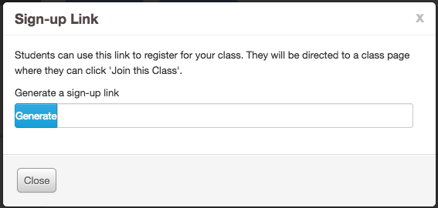

You will be given a link that looks similar to the link below (don't worry about copying this into your web browser, this is just given as an example).

*http://scratch.mit.edu/classes/57468/register/8b71542e29fc4df78c12e3c92eecb8df*

You could share then this link using your preferred method of sharing website links with your students. For example, you could send an email that includes the link to all of your students.

The students could then follow the link to register a *Student* account, that will be a member of the *Class* you created earlier in the activity.

### Create a Sign-up Link

In this part of the activity you will create a *sign-up link*, that students can use to sign up for a *Student Account*.

In the web browser that you have logged in to your *Teacher Account*, go to your *Class* page and click the *Student Sign-up Link* button.

Next, click the *Generate* button and a web link, similar to the example link given above, will appear.

Copy this web link - you will need it in the next step of the activity.

### Register as a Student Account

In this part of the activity, you will use the *sign-up link* you created in the previous steps to register as a student for the *Class* you just created.

Firstly, go back to the web browser that you had opened to log in to the account in the previous section, where you learned about the *CSV Upload* feature, and sign out of that account. Next, paste the web link you generated in the previous steps into the web browser's address bar and go to that website.

You should now see a webpage that explains that you have been invited to join a *Class*. This time, after you accept the invite, you will notice that you are asked to choose a *username* and *password*. Note that, if you use this approach for creating accounts for your students, you will have to make sure that the students understand that their chosen *username* has to be unique and that the *username* should not include names or words that could identify them. One potential disadvantage of this approach is that you do not get to choose exactly what students' *usernames* will be. Consequenty, you may have to review the students' chosen *usernames* to make sure they do not include identifying information.

After choosing a *username* of your own choosing, you will then be asked to provide some personal details. Once you have filled in these details, you will then be signed into this new *Student Account* and you will be able to view the *Class* from the newly created account's perspective.

### Summary

* The *Student Sign-up Link* feature can be used to create a web link that can be shared with your students
* When students follow the link, they can register an account for your *Class* with their own chosen *username* and *password*
* When you use this approach, you cannot easily prevent students from creating *usernames* that contain names or words that might identify them
* Sharing a link with your students may be simple (for example: through email) and so you may find this to be quicker and easier approach for creating accounts than the *CSV Upload* approach

## Which Way Do We Recommend Adding Students?

### An Example using CSV Upload

In the previous parts of this activity we looked at three different approaches for creating *Student Accounts*. Each of this approaches has its advantages and its disadvantages, and the one that works best for you will really depend on your individual classrooms and your students' proficiency with digital technologies.

We will give an example of an approach for utilising the *CSV Upload* approach to create a *Class* of *Student Accounts* that we have used in workshops with teachers, that could also be used with your students.

Firstly, we use a programming language, such as *Scratch*, to create a list of random *usernames* and *passwords*. You can see an example of a Scratch program creates random *usernames* and *passwords* on the workshop website, by following the [Student Account Creator Example in Scratch](https://scratch.mit.edu/projects/163476162/) link on the *Scratch Teacher Accounts Activity* page.

After creating the list of random *usernames* and *passwords* and saving them to a csv file, we would then use the steps in the *Create and Upload a CSV File for New Student Accounts* section of this activity to create the *Student Accounts*.

We would then put the list of *usernames* and *passwords* into a spreadsheet program, such as *Excel*, and add *student name*s and *email addresses* next to each of the *usernames* and *passwords*. An example of the resulting table (with two *Student Accounts*) in the spreadsheet program is given below:

|  |  |  |  |
| --- | --- | --- | --- |
| Teacher Name | Email Address | Username | Password |
| Daniel Deckchair | daniel.deckchair@test.com | SM2017_GreenFrog2 | helloworld1 |
| Benjamin Button | benjamin.button@test.com | SM2017_BlueCat4 | helloworld2 |

After creating this table, we would then give the teachers their *username* and *password* details. The details could be sent to the teachers through email (for example: by using a *mail merge*) or printed out on bits of paper. Each of the teachers would then be able to log in to their newly created *Student Account* and view the *Class* you created.

There are two main reasons that we recommend using an approach for creating *Student* accounts that is similar to the one outlined above:

* By having random *usernames*, you avoid any issues where students create their own *usernames* that contain names or words that identify their personal details
* For classes with 20 or more students, it may take less time to create a spreadsheet, put the usernames and passwords into a csv file, and upload that file than the time it would take to add the students one by one with the *+ New Student* button

# Creating Class Studios

## What are Class Studios?

*Studios* in *Scratch* are collections of projects that you and your students can view and add projects to. You can create *Studios* for a *Class* in Scratch, which we call *Class Studios*.

You can view the *Class Studios* for a *Class* by looking at the *Studios* tab of a *Class* page. An example of a *Studios* tab on a *Class* with 3 studios is pictured below:

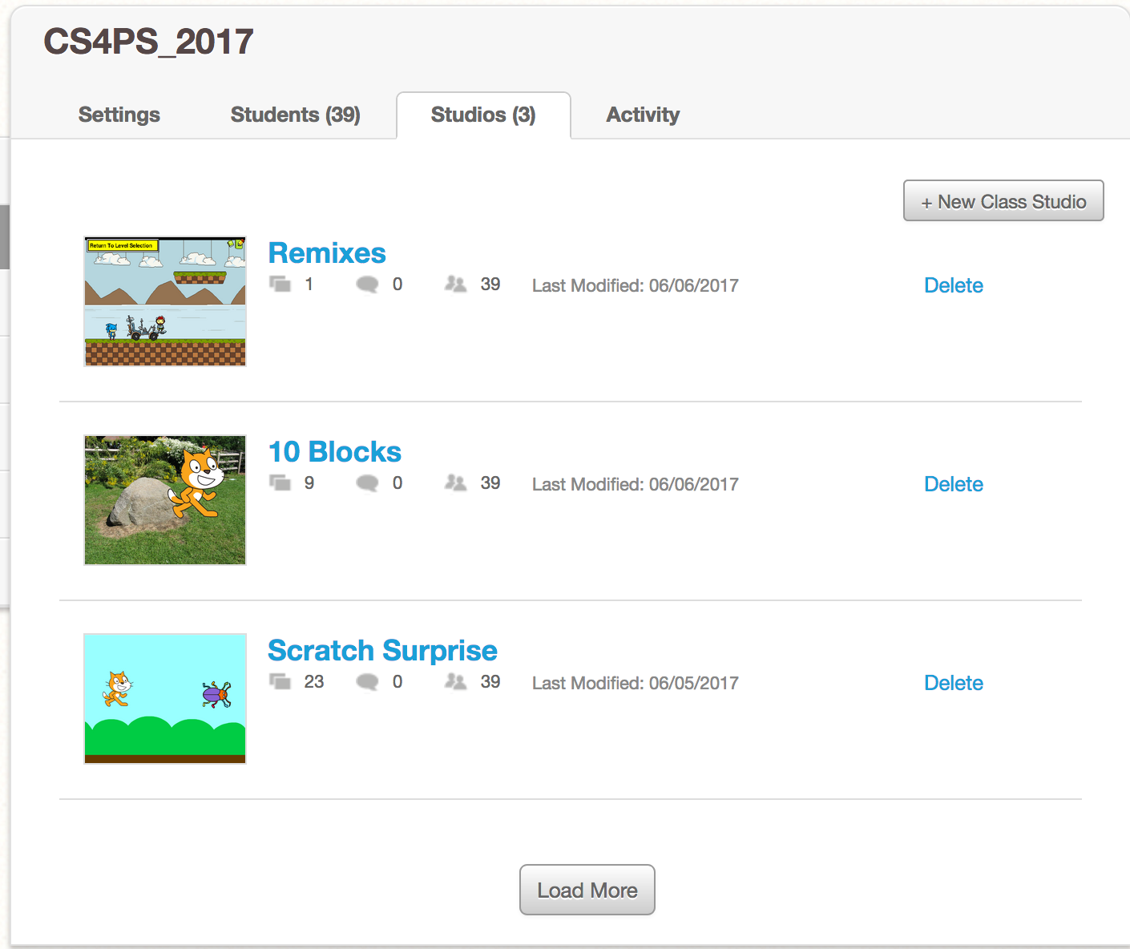

You and your students can add any project that has been *shared* to a *Class Studio*, including any projects that you, your students and other *Scratch* members have created and shared. You can use *Class Studios* in a variety of different ways and you do not necessarily have to use them as a way of collecting your students' projects.

For example, you could use a *Class Studio* to provide students with examples of projects that they could use for inspiration for their own projects. Let's say that you have asked your students to create a game or animated story that has to include a maze. You could create a *Class Studio* and add examples of projects that other *Scratch* members have created and shared (for example: a game where a character has to escape a maze). Your students could then view the projects in this *Class Studio* to help them come up with ideas for their own project.

Alternatively, you may want to create a *Class Studio* for an assessment task. You could ask your students to share and add their project into this *Class Studio* once it is ready to be marked, so that you could see all of the assessment task submissions in one place.

## Create a Class Studio

In this part of the activity you will create a *Class Studio*. Let's say that you have asked the students to find a *Scratch* project that they think is interesting (using the *Explore* link on the *Scratch* homepage, for example) and you would like them to share it with the rest of the class.

To create a *Class Studio*, click the *Studios* tab when viewing a *Class* and click the *+ New Studio* button.

You should see the *Add a New Class Studio* form appear, which will be similar to the image below:

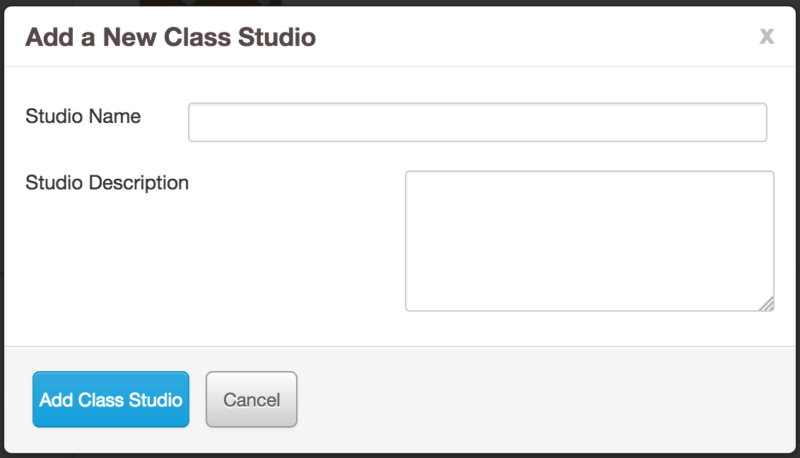

For this example, you could use the following *Studio Name* and *Studio Description*:

* *Studio Name*: Interesting Projects
* *Studio Description*: A Studio for sharing projects that you find interesting

After filling in these textboxes and clicking the *Add Class Studio* button, the form pictured above will disappear and you should now see the *Interesting Projects* studio in your *Studios* tab.

When you click on the *Interesting Projects* Studio link, you will be able to see the details for the Studio, which will look similar to the image below:

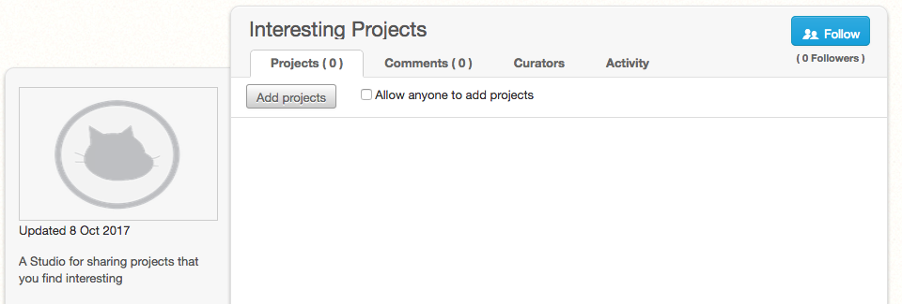

When you create a new *Class Studio*, all of the *Student Accounts* in the *Class* will automatically become *curators* of the *Studio*. *Curators* can view and add projects to a *Studio*.

You may notice the *Allow anyone to add projects* checkbox at the top of the *Interesting Projects Studio* page. When this is checked, anyone with a *Scratch* account can add a project to the *Class Studio*. In most cases, you probably do not want to allow anyone to add projects to the *Class Studio*, so it is probably best to leave the *Allow anyone to add projects* checkbox unchecked. However, there may be some cases where you would allow for anyone with a *Scratch* account to add a project to the *Class Studio*. For example, some of your students may have their own personal Scratch accounts and you might allow them to use their personal account instead of a *Student Account*. When you create a *Class Studio* for an assessment task, you could check the *Allow anyone to add projects* checkbox and consequently the students using their personal accounts would be able to share and add their completed projects to the *Class Studio*. Alternatively, instead of checking the *Allow anyone to add projects* checkbox, you could use the *Invite curators* button in the *Curators* tab of the *Class Studio* to add the students using their own *Scratch* accounts as *curators* to the *Class Studio*.

## Add a Project to the Class Studio

In this part of the activity, you will add a project to the *Class Studio* you created in the previous steps.

There are two ways to add a project to a *Class Studio*:

1. From the *Studio* page, with the *Add projects* button
2. From a project's page, with the *Studios* button

In this activity, we will use the second approach. For more detail about how to add projects to a *Studio* and other features of *Studios*, see the *Scratch Wiki* page about *Studios*, available at: <https://wiki.scratch.mit.edu/wiki/Studio>

Now use the *Explore* feature of *Scratch*, by clicking the *Explore* link at the top of the *Scratch* website, to find a project that you find interesting. Once you find an interesting project that you would like to add to your *Interesting Projects Studio*, click the *Studios* button. An example of an interesting project with the *Studios* button highlighted by a blue rectangle, is shown in the image below:

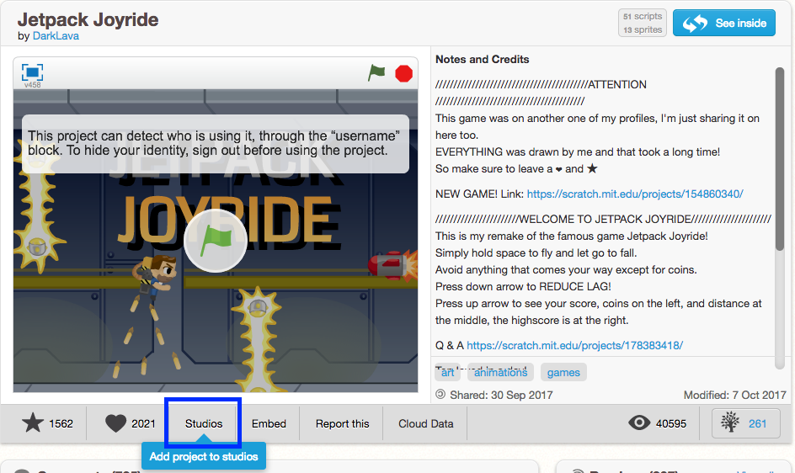

When you click the *Studios* button, a list of *Studio* names with gray ticks next to them will appear. To add a project to a *Studio*, you will have to click the tick next to the appropriate *Studio's* name. After you have clicked the tick for the *Interesting Projects Studio*, the tick will turn green and the project will be added to the *Studio*.

Now, go back to the *Interesting Projects Studio* page and you should see the newly added project.

# Changing Students' Passwords

One of the most useful features of *Scratch Teacher Accounts* is the ability to change *Student Account* passwords. If one of your students forgets their password and cannot login to *Scratch*, you can change their password for them.

To change a *Student Account's* password, you will have to go into the *Students* tab of the *Class* page, find the name of the *Student Account* you want to change the password for, and then click on the *Account Settings* link below their name.

There are two different ways of changing *Student Account's* passwords, which are described in the *Account Options* form shown in the image below:

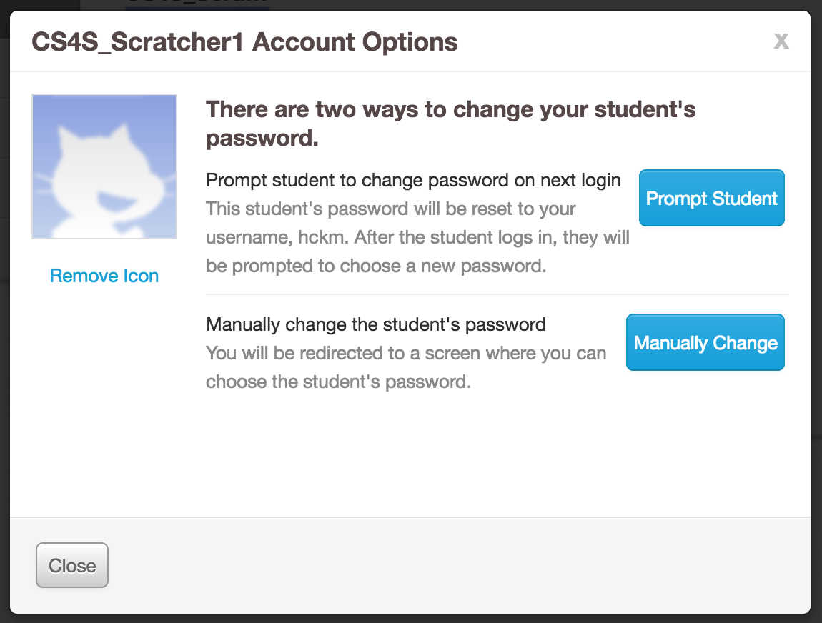

Both ways of changing *Student Account's passwords* describedin the image above are quick and easy ways to get a student that has forgotten their password logged back into their account.

# Viewing Students' Activity

Another useful feature of *Scratch Teacher Accounts* is the ability to view your students' activity on *Scratch*. You can see students' activity by looking at the *activity* tab on the *Class* page.

An example of activity in a *Class* called *CS4S_Scratchers* is shown in the image below:

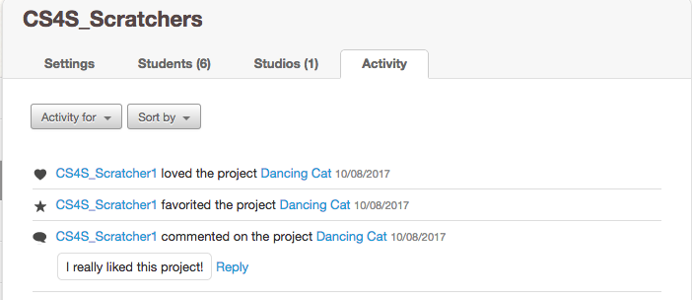

You can see many different types of activities in the *Activity* tab, including when a student:

* shares a project
* comments on a project
* loves a project
* favourites a project

There are some activities will also appear in the *All Class Alerts* section of the *My Classes* page. This is discussed in more detail in the next section.

# All Class Alerts

Some activity in *Scratch* will cause an alert to appear in the *All Class Alerts* section of the *My Classes* page.

Examples of activity that causes alerts are:

* When a student is censored (for example: when they make an inappropriate comment on a project)
* When a student deletes their account

In the image below, you can see an example of an alert caused by a *Student* (with the username *glaretram*) being censored for making an unconstructive comment:

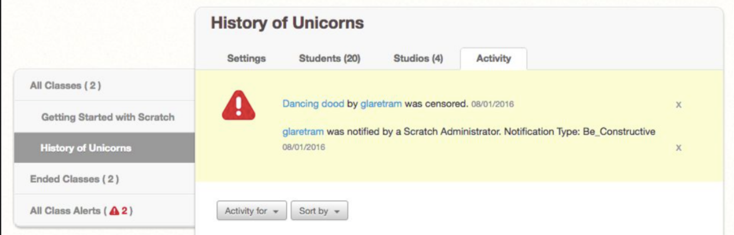

# Conclusion

You have now reached the end of the *Scratch Teacher Accounts* activity - good work!

In this activity you have learned about the following features of *Scratch Teacher Accounts*:

* Creating a *Class*
* Adding *Students* to a *Class*
* Creating *Class Studios*
* Changing *Students'* passwords
* Viewing *Students'* Activity

We hope that working through this activity has helped you understand how to use the features listed above and that these features will be useful for your classroom use, if you do choose to use the online version of *Scratch* and *Teacher Accounts*. This activity will also be available indefinitely on the workshop website for you to refer back to in the future.

If you have questions about planned changes to, or the current limitations of, *Teacher Accounts*, we recommend reading the [Scratch Teacher Account FAQ](https://scratch.mit.edu/educators/faq).